New VM IN Azure

**Steps 1:** Enter virtual machines in the search.

**Steps 2:** Under **Services**, select **Virtual machines.**

**Steps 3:** In the **Virtual machines page**, select **Create** and then **Virtual machine**. The **Create a virtual machine** page opens.

**Steps 4:** In the **Basics** tab, under **Project details**, make sure the correct subscription is selected and then choose to **Create new** resource group. Enter **myResourceGroup** for the name.*.

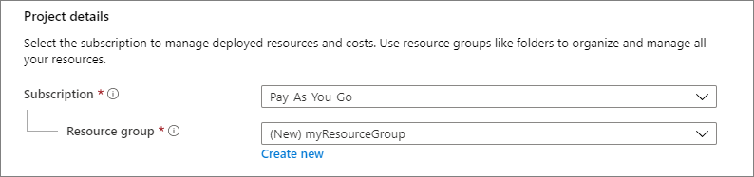

**Steps 5:** Under I**nstance details**, enter myVM for the **Virtual machine name**, and choose Ubuntu 18.04 LTS - Gen2 for your **Image**. Leave the other defaults. The default size and pricing is only shown as an example. Size availability and pricing are dependent on your region and subscription.

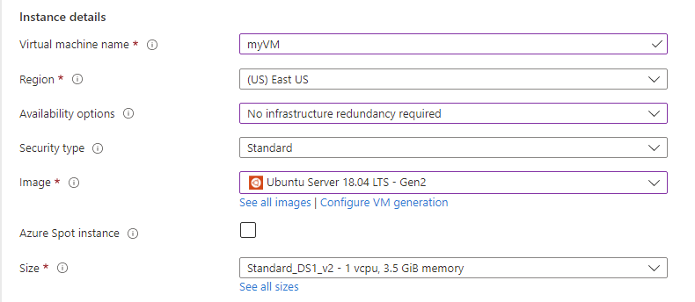

**Steps 6:** Under **Administrator account**, select **SSH public key**.

**Steps 7:** In **Username** enter azureuser.

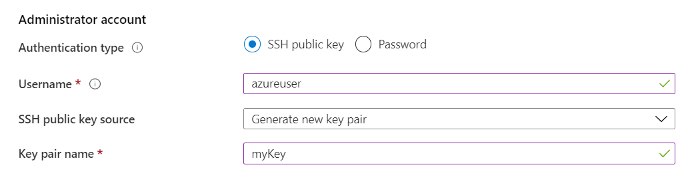

**Steps 8**: For **SSH public key source**, leave the default of G**enerate new key pair**, and then enter myKey for the**Key pair name.**



**Steps 9 :**  Under **Inbound port rules > Public inbound ports**, choose **Allow selected ports** and then select SSH (22) and HTTP (80) also you wan to Allow from the drop-down.

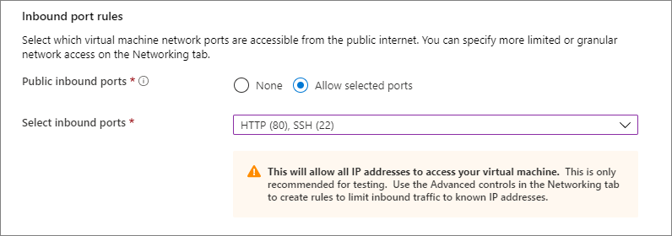

**Steps 10:** Leave the remaining defaults and then select the **Review + create** button at the bottom of the page.

**Steps 11:** On the **Create a virtual machine page**, you can see the details about the VM you are about to create. When you are ready, select **Create**.

**Steps 12:** When the **Generate new key pair** window opens, select **Download private key and create resource**. Your key file will be download as **myKey.pem**. Make sure you know where the .pem file was downloaded; you will need the path to it in the next step.

**Steps 13**: When the deployment is finished, select **Go to resource.**

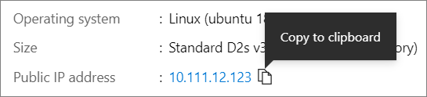

**Connect to virtual machine**

**Steps 13:** Create an SSH connection with the VM.

**Steps 14:** If you are on a Mac or Linux machine, open a Bash prompt and set read-only permission on the .pem file using **chmod 400 ~/Downloads/myKey.pem**. If you are on a Windows machine, open a PowerShell prompt.

**Steps 15:** At your prompt, open an SSH connection to your virtual machine. Replace the IP address with the one from your VM, and replace the path to the .pem with the path to where the key file was downloaded.hed, select Go to resource.

**ssh -i ~/Downloads/myKey.pem [azureuser@10.111.12.123](mailto:azureuser@10.111.12.123) (Used which ip assig your VM)**

**Install web server**

To see your VM in action, install the NGINX web server. From your SSH session, update your package sources and then install the latest NGINX package.

**sudo apt-get -y update**

**sudo apt-get -y install nginx**

When done, type exit to leave the SSH session.

**View the web server in action**

Use a web browser of your choice to view the default NGINX welcome page. Type the public IP address of the VM as the web address. The public IP address can be found on the VM overview page or as part of the SSH connection string you used earlier.

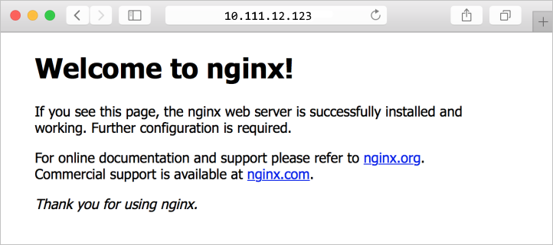

Create User Sigmastream directory and move here Application Installation Setups.

**Note :** For Installation of sigmastream Application we have already create zip file and place on knowlodgeHub teams channel just copy into respective Application and create its services file.

For more information to install app in linux follow respective installation checklist.